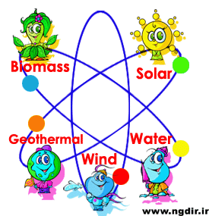
Joining Sentences – Renewable and Non-Renewable Resources

Use an appropriate conjunctive to join the following sentences to make a compound sentence:

1. Renewable resources can be replaced naturally.
Non-renewable resources cannot be replaced naturally.

2. Sunlight is a form of renewable energy.
It is required by almost all living things to survive.

What does it refer to?

3. Coal is a non-renewable fossil fuel energy source.
It is commonly used to run power stations in Australia.

What does it refer to?

4. Oil, coal, gas and nuclear are energy sources.
They cannot be replaced.

5. Renewable energy sources can be used over and over again.
Non-renewable energy sources cannot be used again.

